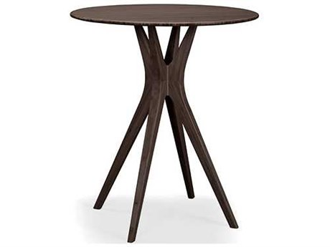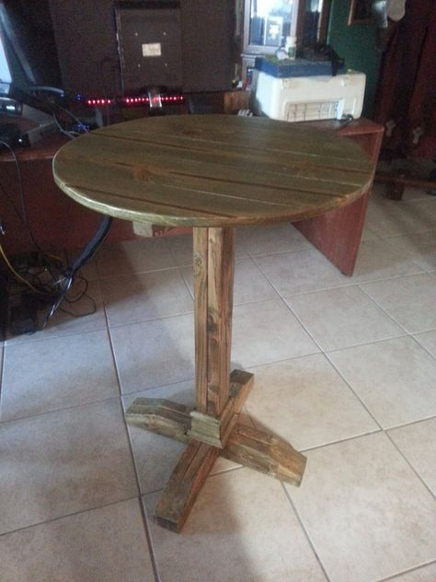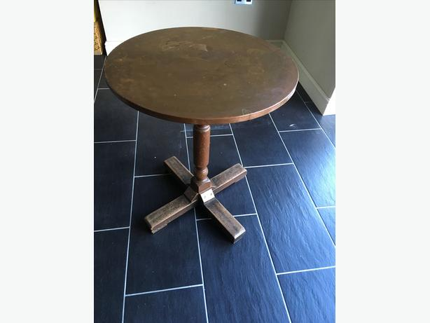

. Wooden top

. Round for smaller off table

. Rectangular for larger table

. Simplistic design

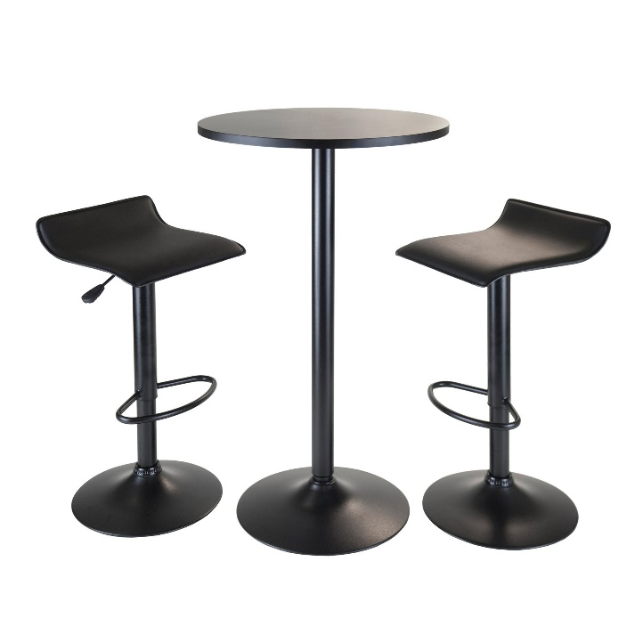

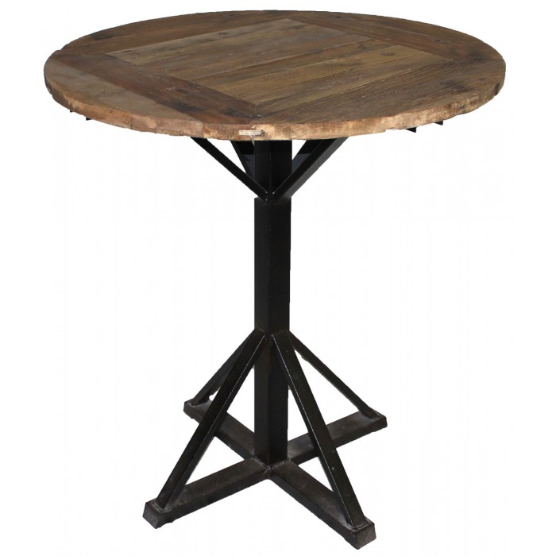

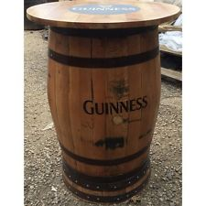

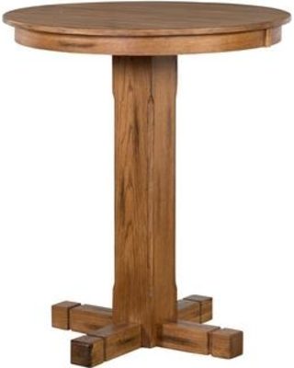

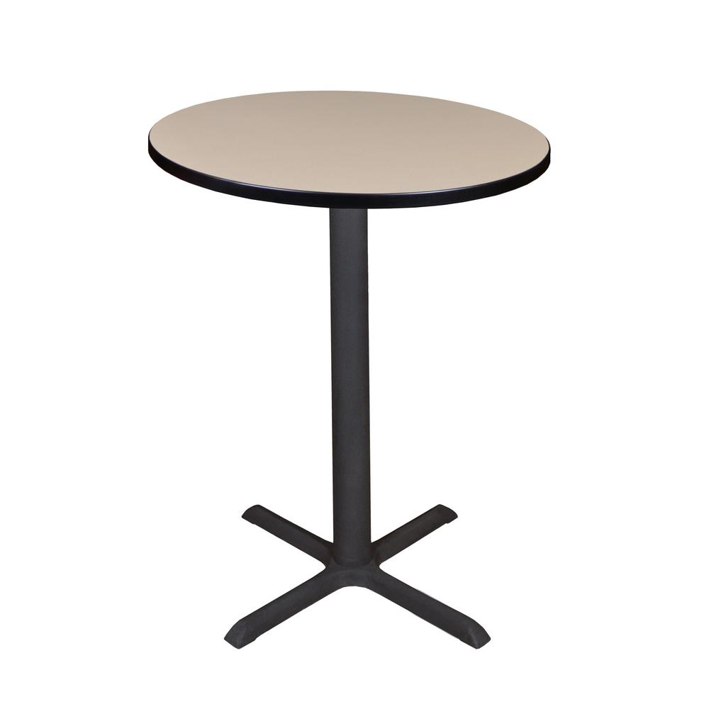

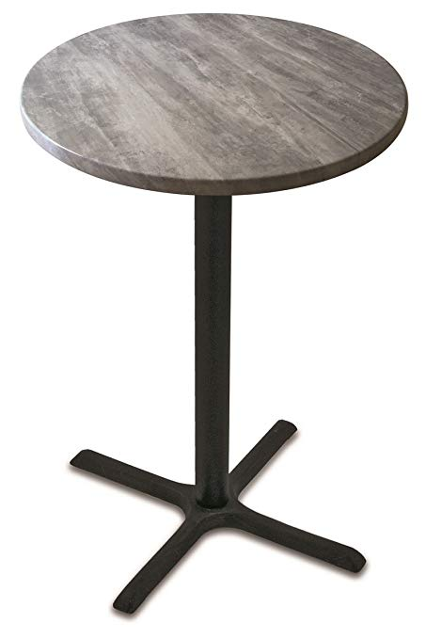

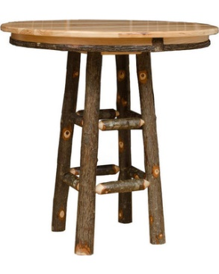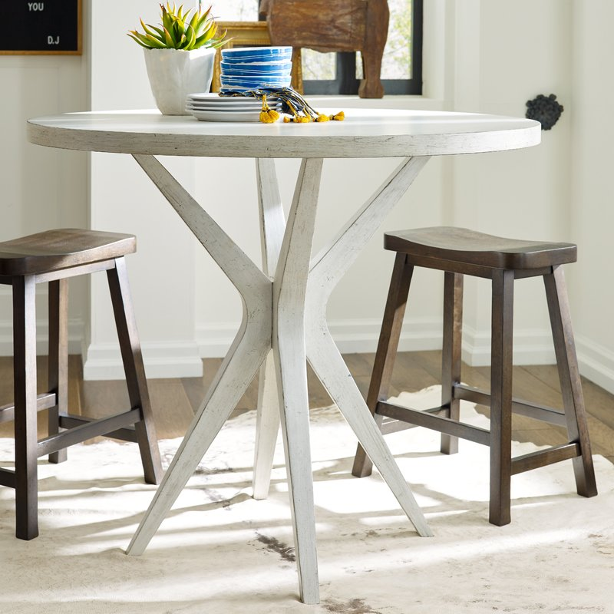

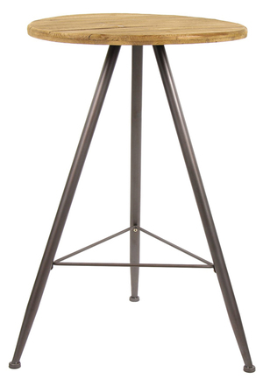

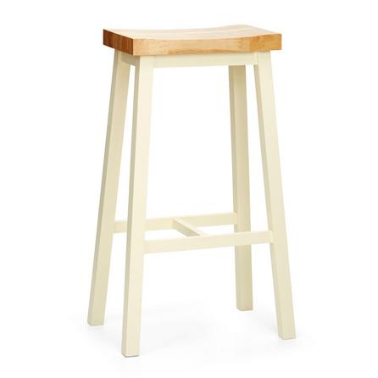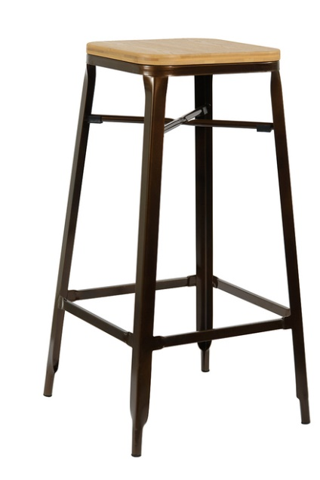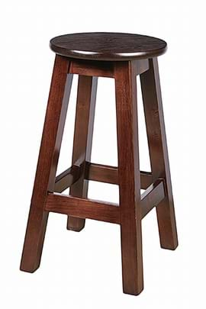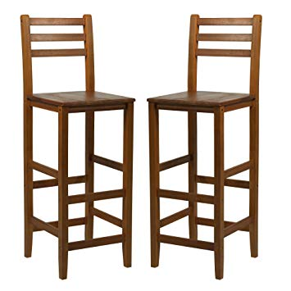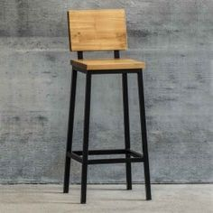

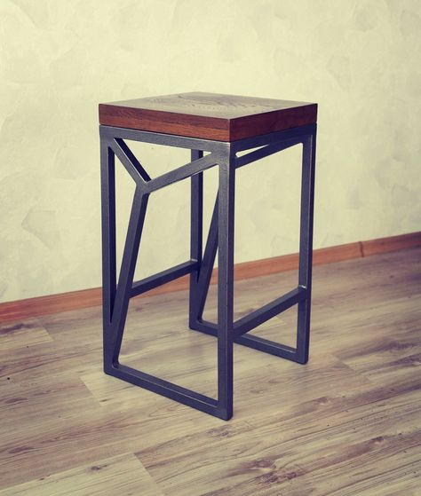

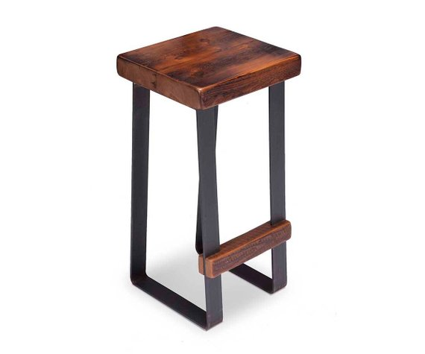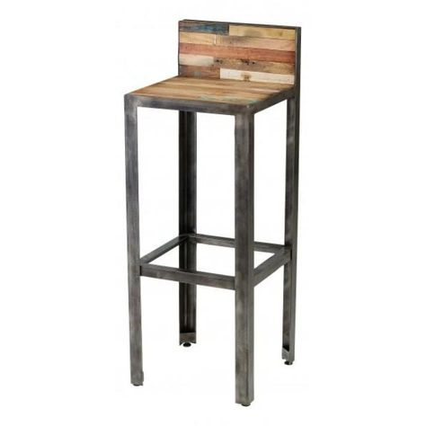

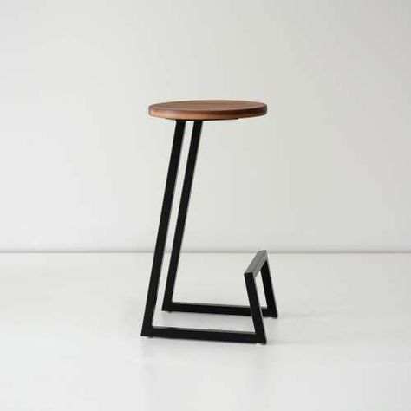

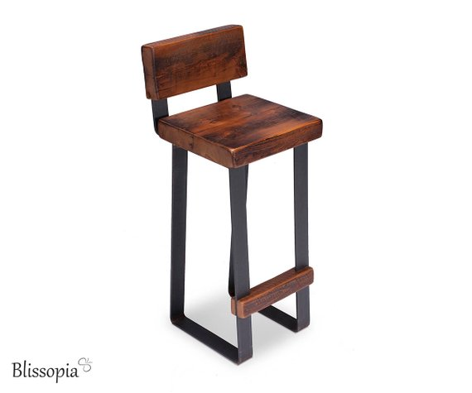

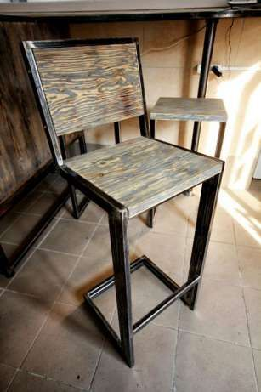

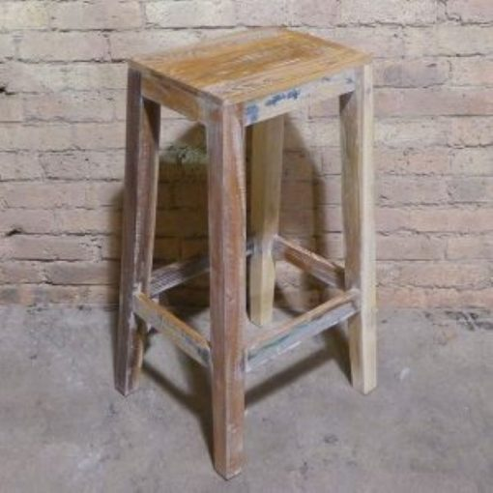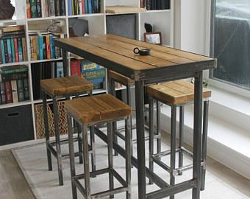

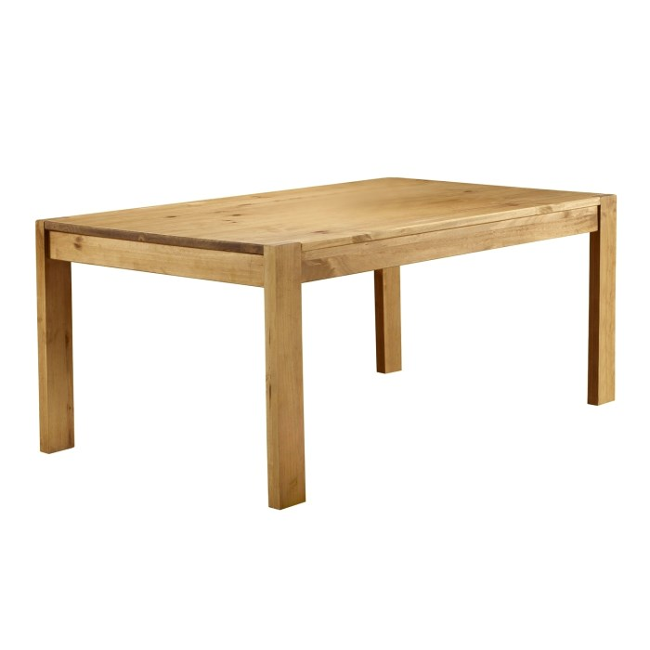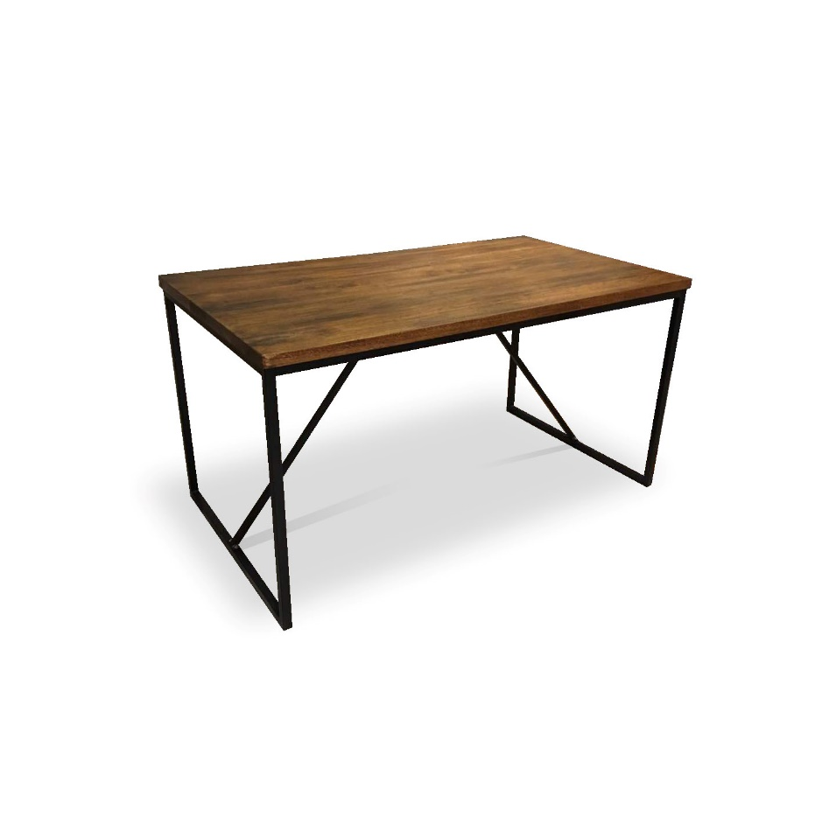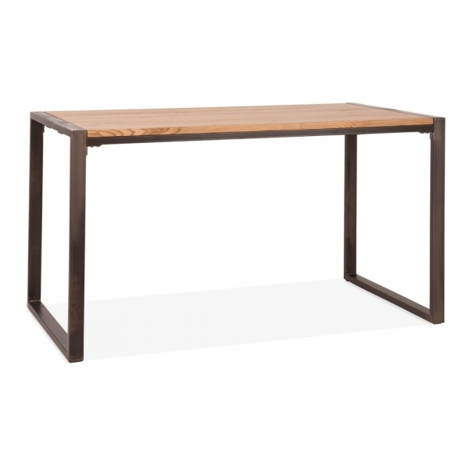

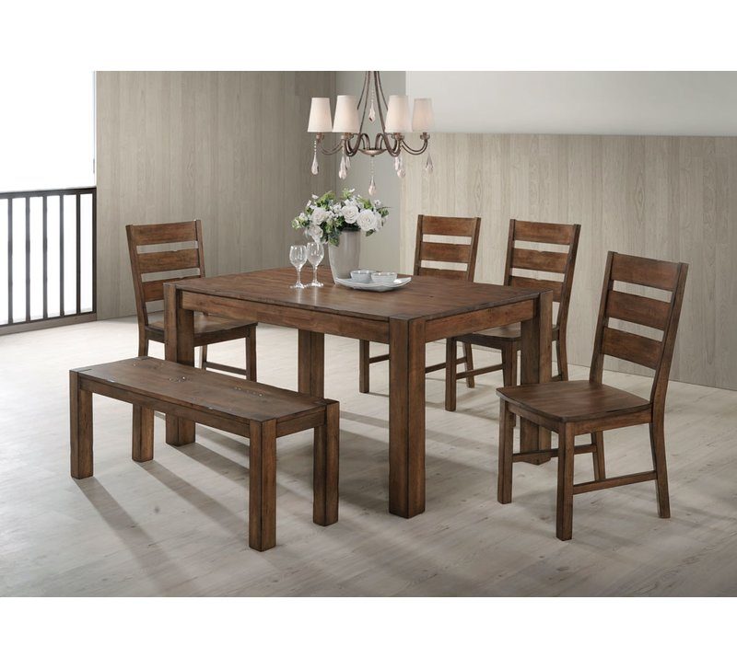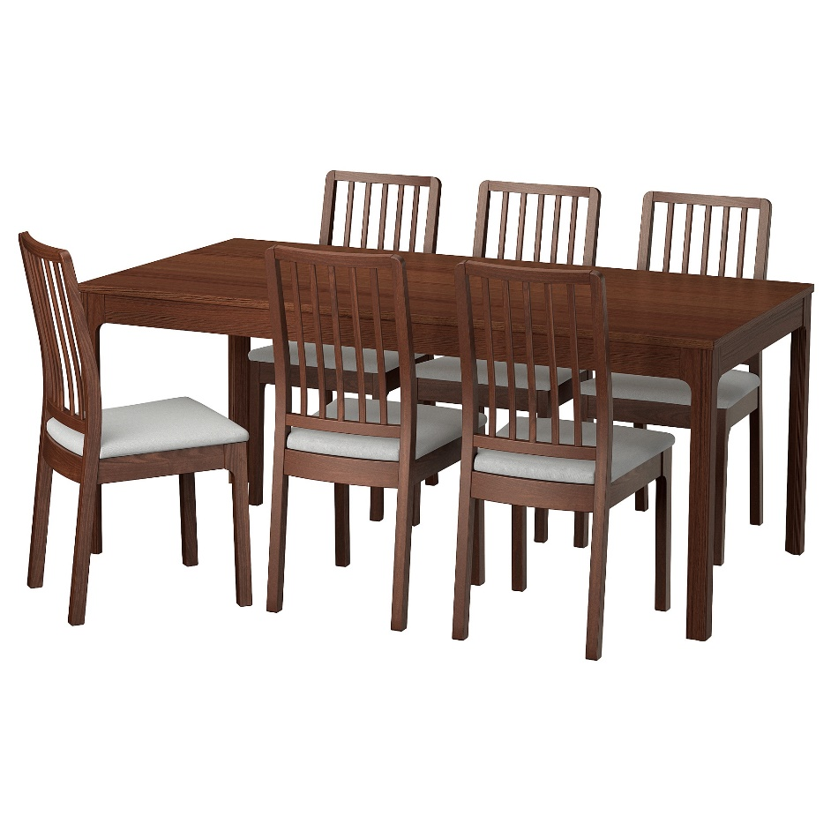

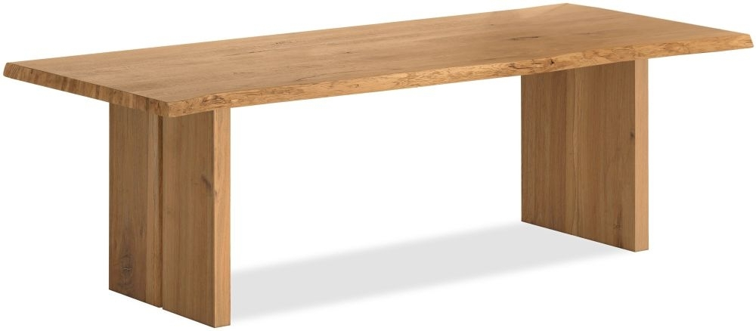

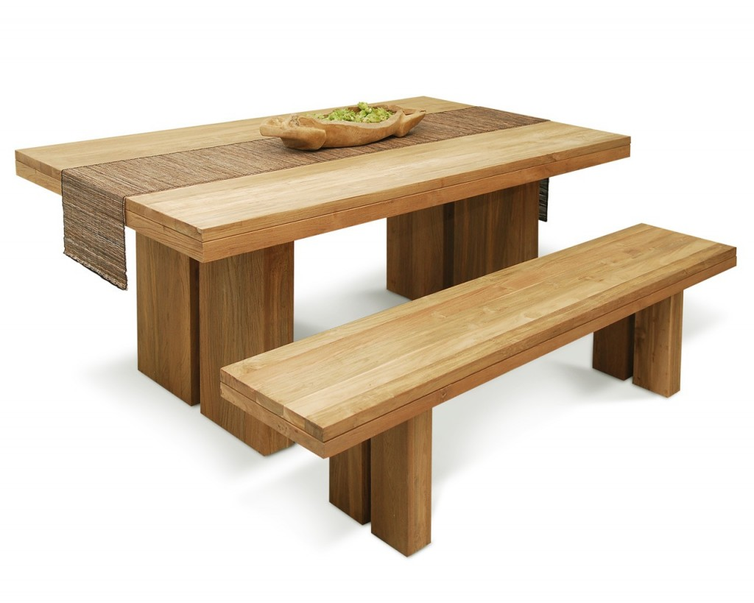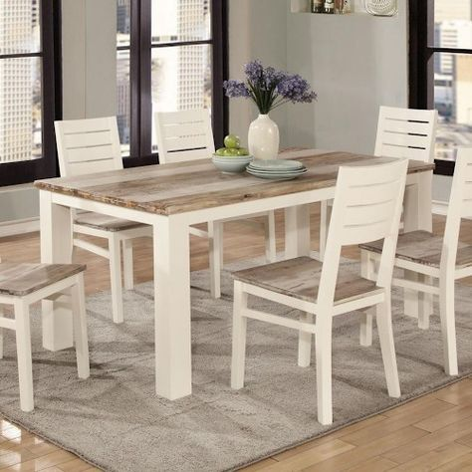

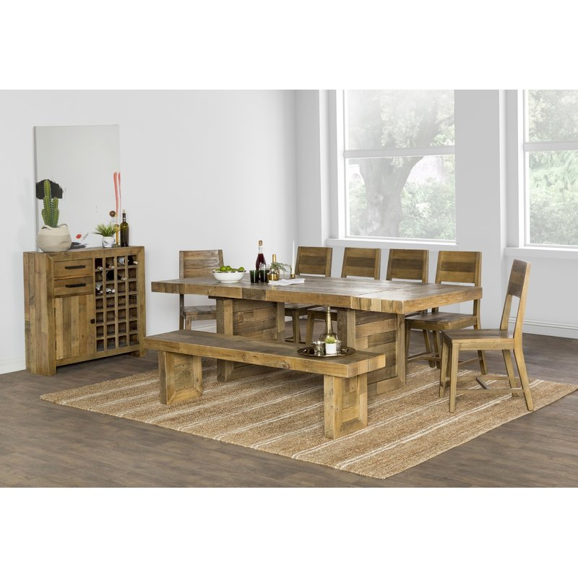

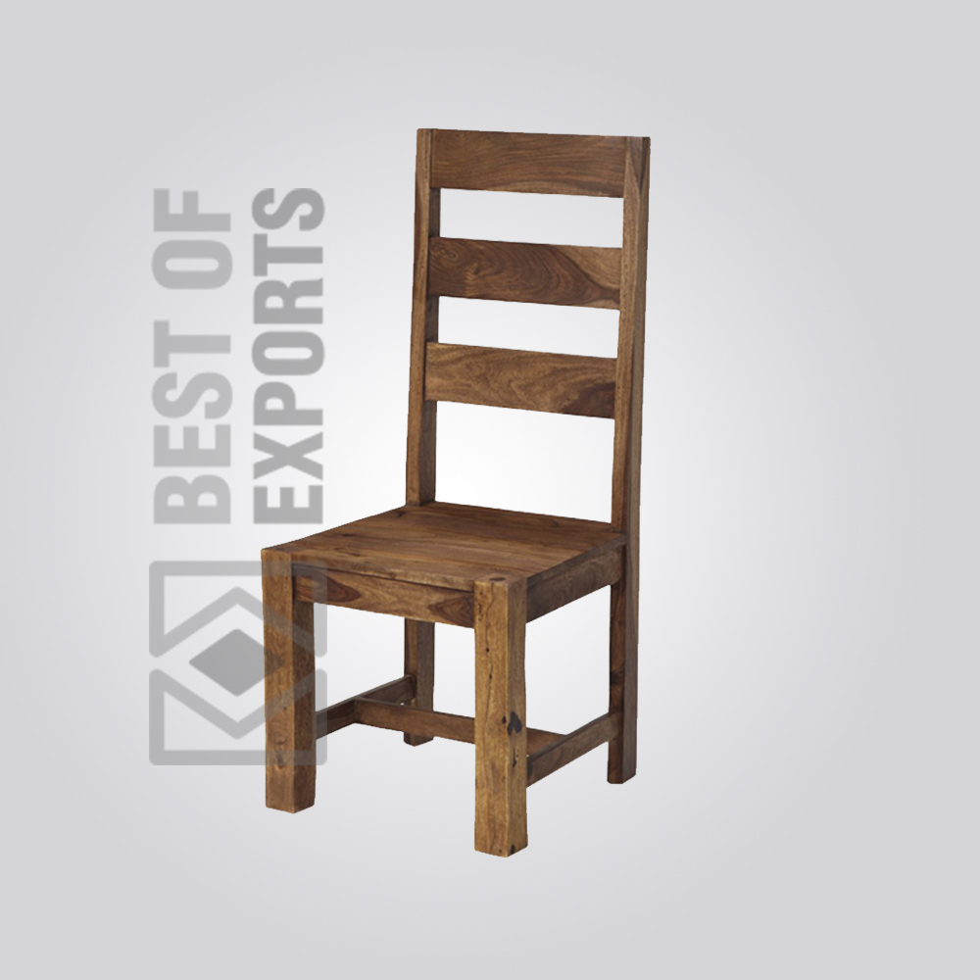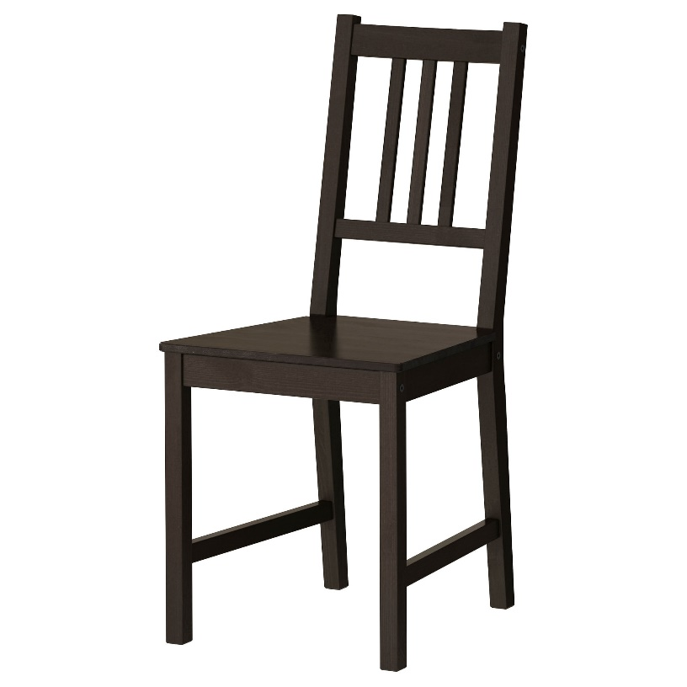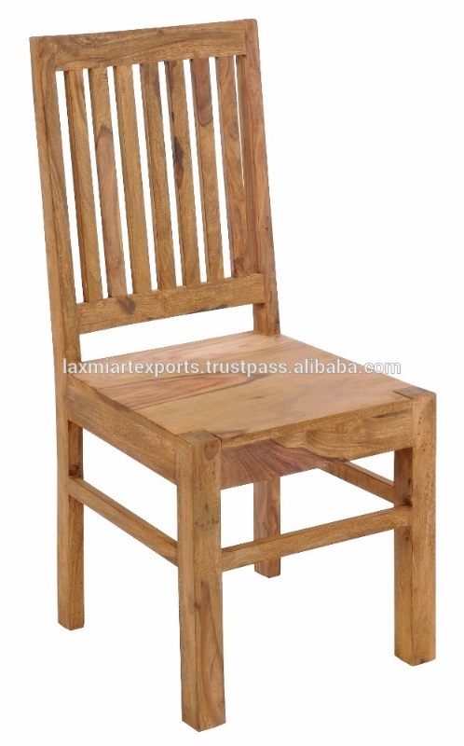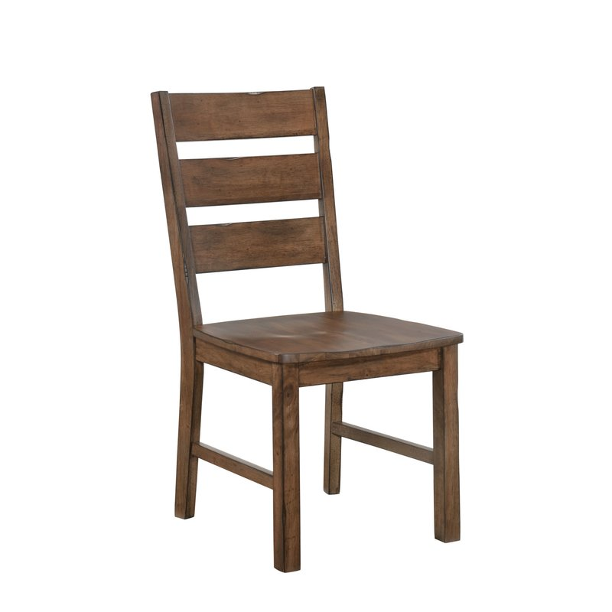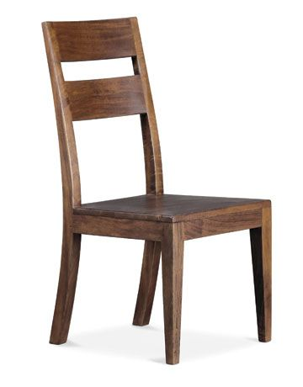

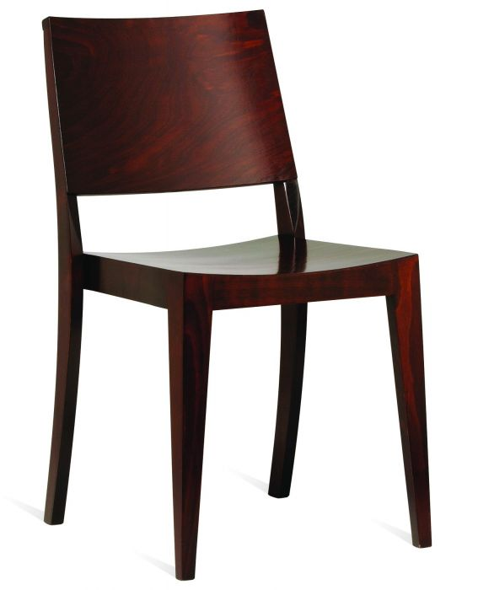

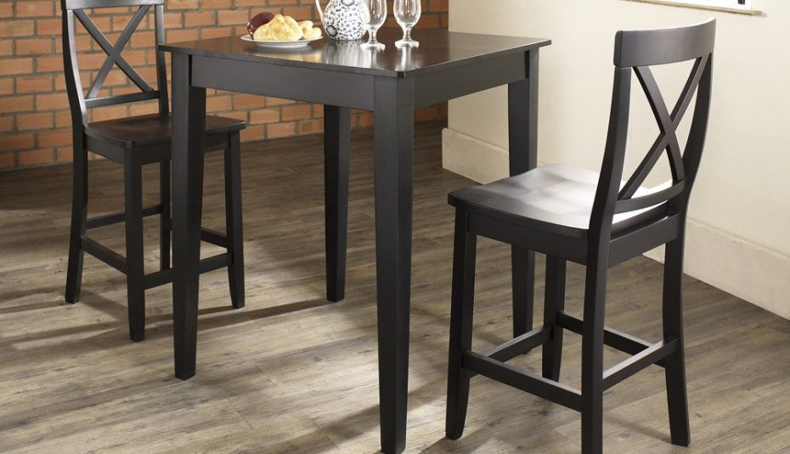

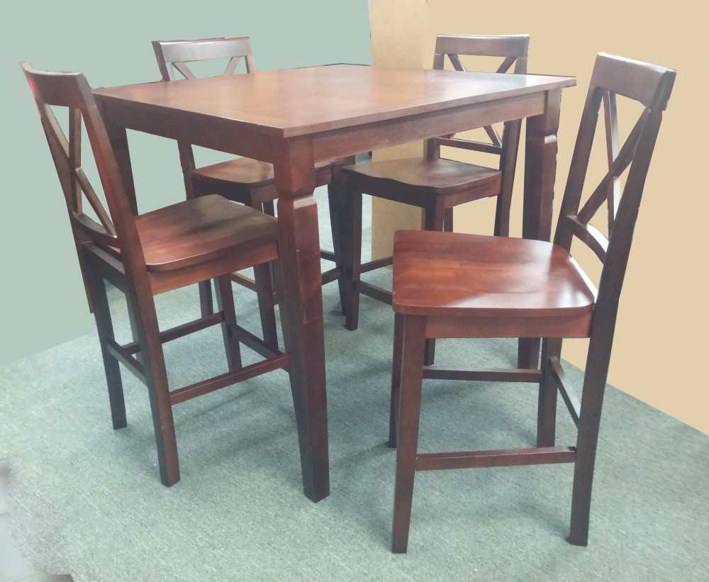

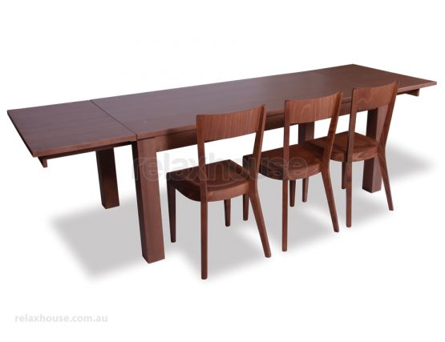

Image Reference (Round Table):

<https://www.google.com/search?rlz=1C1GCEA_enGB832GB833&biw=1920&bih=969&tbm=isch&sa=1&ei=twdkXKOAO_TlxgP8nLKQBA&q=round+pub+table&oq=round+pub+table&gs_l=img.3..0l5j0i7i30l4j0i5i30.907823.908774..909124...0.0..0.47.261.6......0....1..gws-wiz-img.......0i8i7i30.2Gn-fQsHrAg#imgrc=1fLDnHA45PeDoM>:

<https://www.decoetcompagnie.com/pub-round-bar-table-pomax,us,4,32383.cfm>

<https://www.wayfair.com/furniture/pdx/rachael-ray-home-austin-round-pub-table-qbbg1377.html>

Image Reference (Stools)

<https://www.google.com/search?rlz=1C1GCEA_enGB832GB833&tbm=isch&q=wooden+pub+stools&chips=q:timber+bar+stool,g_1:reclaimed:KuuUGTixBJ0%3D&usg=AI4_-kSFztMUVHZ0SHn7qjvX9Tdbw29KcQ&sa=X&ved=0ahUKEwjtjfCL5LjgAhXvSRUIHSeRC7oQ4lYINSgI&biw=1280&bih=913&dpr=1#imgdii=xNkce1TN7h5jcM:&imgrc=CJy00LEpfRlxfM>:

<https://www.furniturewithasoul.com/marietta/product/reclaimed-wood-stool/>

<https://www.amazon.co.uk/HOMCOM-Hardwood-Backrest-Breakfast-Conservatory/dp/B07FLBZPLD>

<https://www.dunelm.com/category/home-and-furniture/furniture/sofas-and-chairs/bar-stools?sku_id=30563383&cm_mmc=pla_google-_-Furniture_Sofas_Bar+Stools_%5BGOO-PLA-SOFA-BARSTOOL%5D-_-BAU-_-keyword&gclid=EAIaIQobChMIhMjA0-K44AIV7ZTtCh2zOw3AEAQYAyABEgIUvfD_BwE>

<https://www.pinterest.com/pin/478507529148409291>

<https://www.etsy.com/listing/546405728/bar-stool-with-reclaimed-wood-seat-and>

<https://www.etsy.com/uk/listing/546407098/bar-counter-table-stool-with-back?ref=landingpage_similar_listing_top-1>

Image Reference (Rectangular Table):

<https://www.cultfurniture.com/furniture-c10/tables-c9/dining-tables-c39/gastro-metal-dining-table-solid-elm-wood-rustic-140cm-p10550>

<https://ruma-home.com/product/tristan-industrial-table-140cm/>

<https://www.birchlane.com/furniture/sb1/rectangular-dining-tables-c1805508-a1278~2253.html>

<https://furniture123.co.uk/p/emerson-solid-pine-dining-table-emr002>

<https://www.roseandgrey.co.uk/nordic-wooden-dining-table>

<https://www.wayfair.com/furniture/pdp/mistana-maci-solid-wood-dining-chair-mitn2077.html?domain=golfreviews.us&SSAID=314743&SSAID=314743&refid=SS314743&creative=65867&m=11035&sscid=21k3_bhf70>

<https://www.relaxhouse.com.au/product/walnut-designer-modern-dining-chair>

<https://spiritcdl.com/post/>